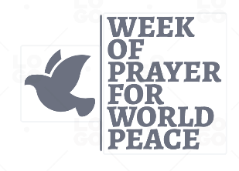

ORDER FORM FOR THE 2023-24 WPWP PRAYER RESOURCE:
Please complete and return either by post or email or leave a phone message
POST: WPWP c/o 112 Whittlesey Road, March, PE15 0AH
EMAIL: wpwp2021@yahoo.com
PHONE: 01354 654214
NAME ______________________________
ADDRESS _______________________________________________________________
PHONE ________________________________________
EMAIL __________________________________________________

Please send me _____________ copies of the WPWP 2023 Prayer Resource and _______ copies of the Young People’s leaflet.
If you would like to make a donation, cheques to ‘Week of Prayer for World Peace’ can be sent with your order or by bank transfer the details are: (please indicate your name on the donation) Bank: Lloyds,Bexleyheath Sort Code: 30-90-76 Account Number: 00049837 IBAN: GB62 LOYD 3090 7600 0498 37

